

Dr. Jonathan, Johns inc.

2022-08-26

Dr. Johns

417 Gonzales Wells Suite 357, Johnsonside, VT 97148

Phone: 2156870814

Fax: 7786574470

**Re:** Kara, Davidson

**PHN:** 6435351251

**Birthdate:** 08-Oct-1960

**Address:** 208 April Islands Apt. 642, Matthewberg, CT 52652

**Patient number:** 8331931993

To Whom It May Concern:

This is a medical letter to state the above patient is pregnant with expected delivery date of 29-Jul-2025. Hoping this information is satisfactory for your requirements.

Thank you.

Sincerely,

Dr. Jonathan, Johns

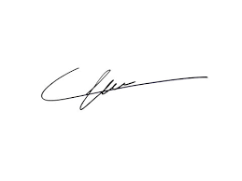

FRCS© NCMP

Clinical Assistant Professor, UBC

Department of Obstetrics and Gynecology SMH